Brennen Boese & Juan Canseco

CST407 Cryptography

Homework 1

1. See Code.

Specifications: Place string into text file labeled fubar.txt inside the executable folder. The string can container spaces, special characters, upper and lower case. The output will be scrubbed of all these items listed and output the new string into a file labeled output.txt where all spaces, special characters, and uppercase letters will be removed.

1. See code & #1 answer.
2. See Code.

Specifications: Place string into text file labeled fubar.txt inside the executable folder. The string can container spaces, special characters, upper and lower case. The output will be scrubbed of all these items listed and output the new string into a file labeled output.txt where all spaces, special characters, and uppercase letters will be removed.

The program goes through and uses each key to decrypt a new string. The decrypted string is then searched for vowels. If vowels are found then the key and the decrypted word is placed into a map<>, then the map is searched for the decrypted word with the most matches of English words we have listed in the program.

1. See code & #3 answer.

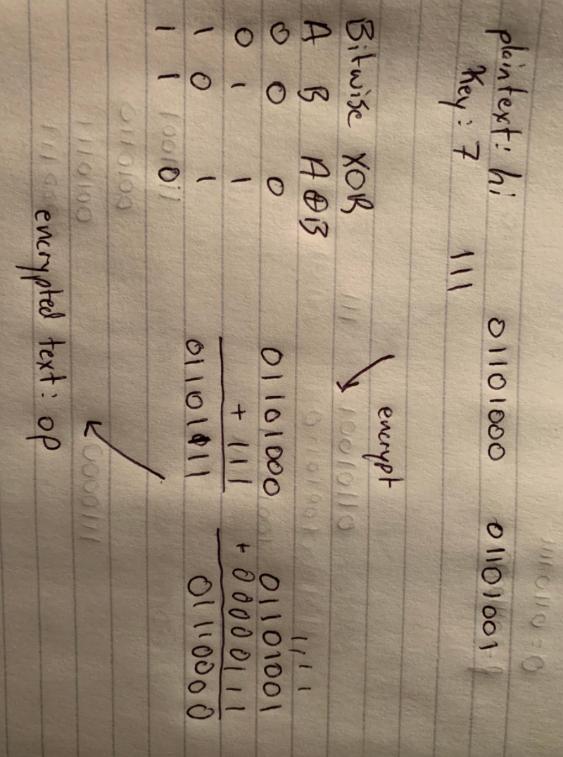

1. 50% to Brennen. 50% to Juan.